INVENTORY MANAGEMENT SYSTEM FOR RETAILERS

|  |  |
| --- | --- |
| **Date** | October 2022 |
| **Team ID** | PNT2022TMID05082 |
| **Project Name** | Inventory Management System for Retailers |
| **Maximum Marks** | 2 Marks |

# ABSTRACT

Inventories are raw materials, work-in-process goods and completely finished goods that are considered to be the portion of business’s assets that are ready or will be ready for sale. Mismanaged inventory means disappointed customers, too much cash tied up in slower sale and warehouses. This inventory is eliminated paper work, human faults, manual delay and speed up process. This inventory management system will have the ability to track sales and available inventory, tells a shopkeeper when it’s time to reorder and how much to purchase. Inventory management system is windows application developed for windows operating systems which focused in the area of inventory control and generation. The advantage of having a good inventory system management can increase the efficiency of the operations, reduce the cost, and maximize the profit.

Keywords: Database, Inventory, public, software.

# INTRODUCTION

The problem of inventory control is one of the most important in organizational management. As a rule, there is no standard solution – the conditions at each company or firm are unique and include many different features and limitations. An occurring task of the mathematical model’s development and determining the optimal inventory control strategy is related with this problem. Features of inventory management models are that the resulting optimal solutions can be implemented in a fast-changing situation where, for example, the conditions are changed daily. There is a need for new and effective methods for modelling systems associated with inventory management, in the face of uncertainty.

Uncertainty exists regarding the control object, as the process of obtaining the necessary information about the object is not always possible. The solution of such complex tasks requires the use of systems analysis, development of a systematic approach to the problem of management in general. Inventory models are distinguished by the assumptions made about the key variables: demand, the cost structure, physical characteristics of the system. These assumptions may not suit to the real environment. There is a great deal of uncertainty and variability.

PROBLEM STATEMENT

# INCONSISTENT TRACKING

Using manual inventory tracking procedures across different software and spreadsheets is time-consuming, redundant and vulnerable to errors. Even small businesses can benefit from a centralized inventory tracking system that includes accounting features.

# WAREHOUSE EFFICIENCY

Inventory management controls at the warehouse is labor-intensive and involves several steps, including receiving and put away, picking, packing and shipping. The challenge is to perform all these tasks in the most efficient way possible.

# INADEQUATE SOFTWARE

To scale inventory management software to support complex logistics, it needs to integrate with your existing business process platforms. The difficult task is choosing from hundreds of inventory management solutions and mastering a host of features that require training and ongoing support.

# PERFORMANCE REQUIREMENTS

The following performance characteristics should be taken care of while developing the system:

User friendliness: The system should be easy to learn and understand so that new user can also use the system effectively, without any difficulty.



User satisfaction: The system should meet user expectations.



Response time: The response time of all the operations should be low. This can be made possible by careful programming.



SYSTEM REQUIREMENTS

# 1.SOFTWARE REQUIREMENTS

* PyCharm [Community edition]
* Kubernetes
* Docker
* MySQL
* IBM DB2

# 2.HARDWARE REQUIREMENTS

* Pentium III processor
* 256 MB RAM
* 20GB Hard Disk

# SYSTEM ARCHITECTURE

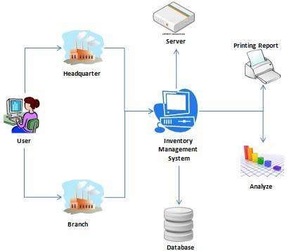

# 3-Tier Architecture

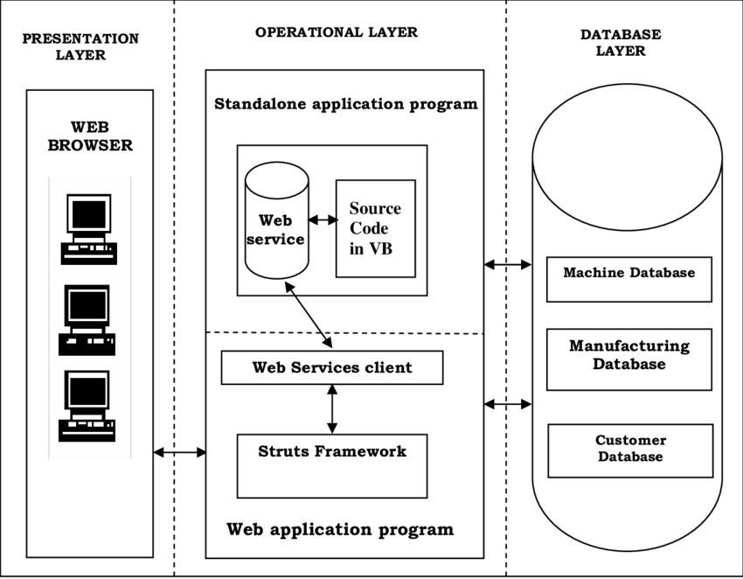

# AUTHENTICATION

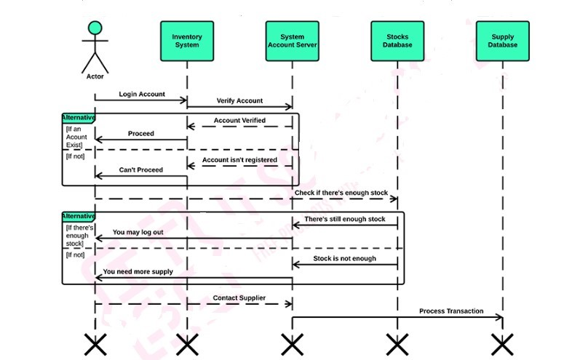

# SYSTEM REQUEST SALES-AND INVENTORY MANAGEMENT SYSTEM • PROJECT SPONSER

The person who initiates the project is the owner of Store and the workers together with the owner serves as the primary point of contact for the project.

# • BUSSINESS REQUIREMENT

The system will be the first system used by Store thus it will be made as offline system. The system provides enables the owner to keep track on the inventory level of each good with presents of database. The functionalities that the system should have been as follows:

* User LogIn
* Admin Login
* Process Scales
* Update Inventory Database
* Generate report
* Notification on low Inventory level

FEASIBILITY ANALYSIS

#  Technical Analysis

Technical aspect is the most important part in the system development. As the system is offline based, visual basic will be used to develop the interface and the functions of the database. For the database aspect, Microsoft Access will be used which will link the system interface with the data storage. The exposure gain in ‘Business System Development’ subject through course curriculum has given the author the credibility to develop the program as specified. Moreover, online tutorial on system development also vastly available on the internet which will helps in development stage.

#  Economical Feasibility

Basic analysis has been done in investigating the economical feasibilities of the project. The financial analysis demonstrates that the new system will reveals a positive economic feasibility. In term of software designing and license, it can be found on open source in the Internet thus, owner does not need to purchase the software from the vendor. New system will be requiring extra cost on the hardware implementation part. Looking at current situation of the store, the owner has to purchase a desktop to use the system and also bar code to scan the barcode of the systems.

Even though initial cost of implementation is quite high, the owner will enjoy the benefits of switching to the new system in a long term in term of efficiency and effectiveness of business operation. Firstly, they can reduce the cost or the loss incur due to overstock of food-based products that have expired date. Secondly, the system also reduces the risk of having products that out of stock in the store will eventually cause the customers to find the products in other store. Besides, customers satisfactions also expected to increase as the system will provide them with proper receipt for references upon implementation. Turnover rate of each item reported by the system also helps the owner to make appropriate inventory level decision of the item precisely. Apart from all the benefits, costs related to manual works and documents required to maintain the inventory level will be reduce and eliminated gradually as all the data will be stored in the database.

#  Operational Feasibility

The risk of familiarity with the application is medium because the users/staff never used to computerize system. Thus, there is a need for brief introduction on handing the system in order to implement the system. Besides, as most of the staffs in the store are not IT literate, the to-be system will be user-friendly and easy to operate.

Administrator: The administrator will have easier access of inventory data and update it. He prints out daily and weekly statistical report to check on the store business performance.

The Staff: The to-be system will ensure the transaction handle by them will directly send to database. Thus, the staff will gain advantage upon the implementation of the system as this can reduce the human-error by calculating the transaction manually and compare it with the amount of money in the cashier and the inventory level available.

NON-FUNCTIONAL REQUIREMENTS

# • OPERATIONAL REQUIREMENTS

The system is required to be operated in the computer. Since Store does not have one, they have to purchase in order to install the system. It has to be able to update database based on point of sale of each customer. Moreover, the system can generate daily, weekly and monthly report on sales performance. • SECURITY REQUIREMENTS

Not all staff can access the system apart from the staffs that are responsible in processing customers’ sale at the cashier. The sales information is confidential and only accessible by the admin.

• CULTURAL AND POLITICAL REQUIEMENTS

No special cultural and political requirements are anticipated

# FUNCTIONAL REQUIREMENTS

* Log In
* Process sale

Allow user to scan items purchase by each customer. The system will display the description of the items and process the total sales and generate receipt for the customers

* Tracking inventory level Admin able to track the inventory level of each item in line with the sales made.
* Update database

Allow admin to update the inventory data in the database that will be used when processing sale.

* Generate report

Reports on daily, weekly and monthly sales of the store will be generating so that the owner can view the performance of the business and take appropriate actions.

RESULTS AND DISCUSSION

# FRAMEWORK OF THE SYSTEM

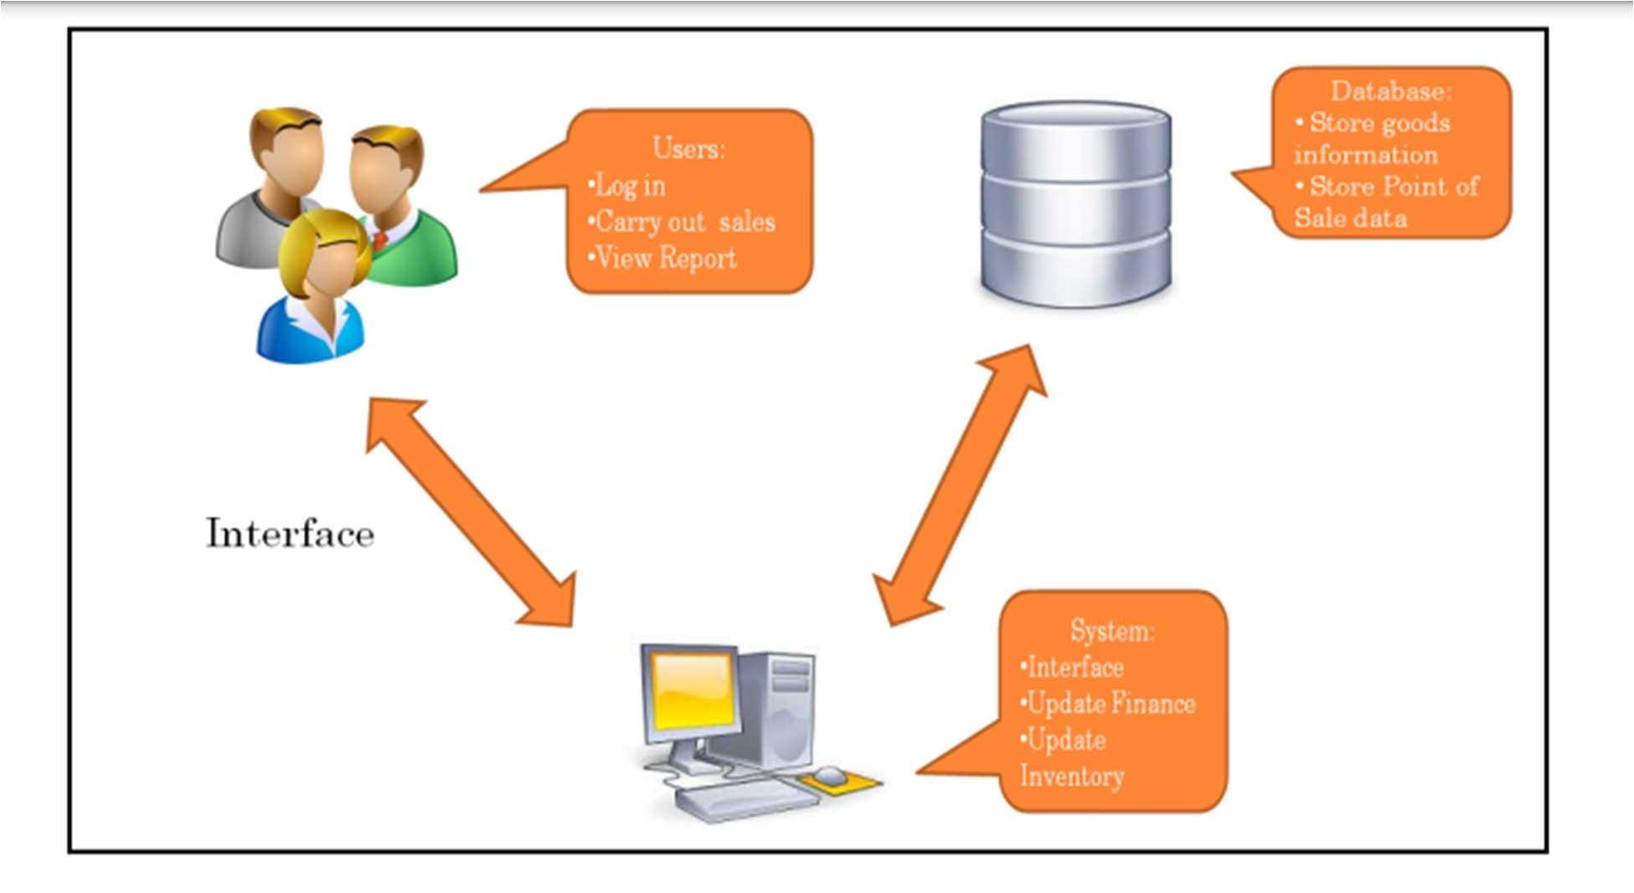

The users here include:

* Administrators of the system who can log in and modify the information of goods
* Staff who are responsible for processing sale The system will include:
* A user-friendly interface
* A database: to store all the inform

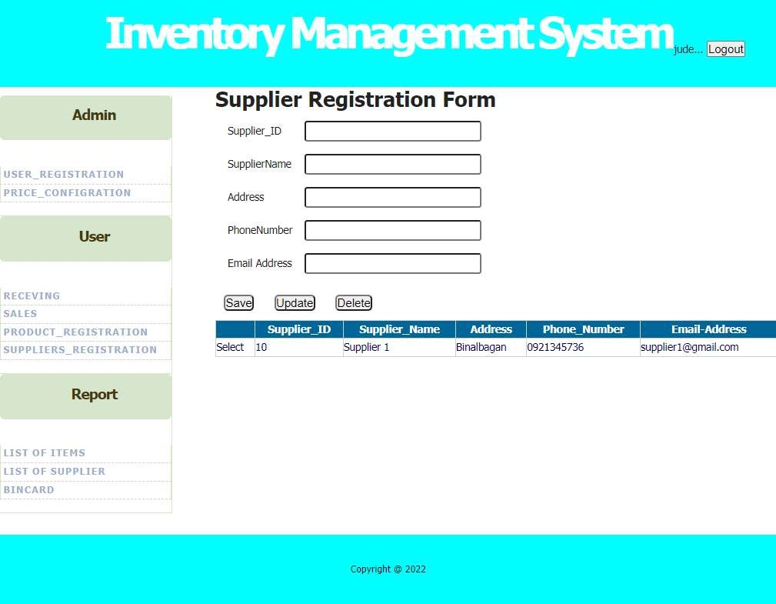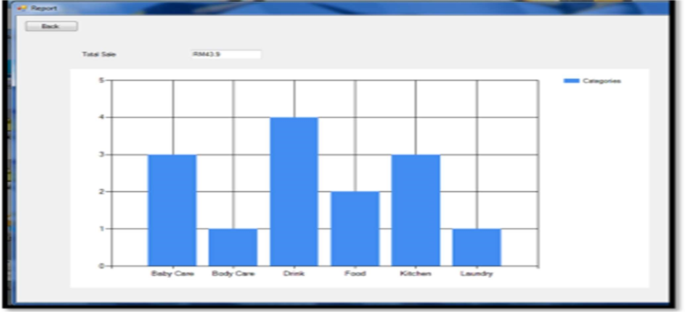

REPORT PAGE

# CONCLUSION

In summary, the project works is relevancy to the objectives set. Thus, activities of developing the system which is planning and analysis is based on the result retrieved from the interview on observation. Not only that, as this would be the first computerized system that will be used by the store, the functions only focused on solving major problem which is inventory management problem. The interfaces design is also categorized as user friendly due to lack of IT background of the workers which means the system can be handle by people not even from IT background. Due to time constraints, it is not possible for the developer to implement many functions in the system, thus the developer has few future works suggestions for continuation. By having this integration, Store can practice Just-In-Time inventory where the store does not need to hold many stocks which is not a good practice of inventory control.

# REFERENCES

Tim Crosby (2007), How Inventory Management Systems Work Retrieved 22, Jun 2013 from http://money.howstuffworks.com/how-inventorymanagementsystems-work1.htm



Wikipedia (2013), Inventory Management Software Retrieved 22 Jun 2013 from http://en.wikipedia.org/wiki/Inventory_management_software



http://utpedia.utp.edu.my/



https://www.readcube.com/articles/10.13165/vse-15-5-1-03

